**ANNOTATION**

of the dissertation work for a degree of Doctor of Philosophy

Theme: «Comparative analysis of biocompatibility of decellularized xenogenic peritoneum and acellular dermal collagen «Permacol» at plastic surgery of the anterior abdominal wall defects»

(experimental work)

Specialty: 6D110100 Medicine

**Performer:** doctoral student Lyubov Vyacheslavovna Brizitskaya

**Scientific supervisor:** Candidate of Medical Sciences, Professor, N. T. Abatov, Department of Surgical Diseases, NC JSC «Karaganda Medical University»

**Scientific consultant:** Candidate of Medical Sciences, researcher, L. L. Akhmaltdinova, NC JSC «National Scientific Cardiac Surgery Center»

**Foreign scientific consultant:** M.D., Ph.D. Professor Yoshihiro Noso, Hiroshima International University, Hiroshima, Japan

Republic of Kazakhstan

Karaganda, 2023

**Relevance**

Endoprostheses for repair of the anterior abdominal wall hernia have undergone significant changes in their evolution, expanding the arsenal from single-layer polypropylene meshes to composite mesh prostheses, 3D implants with shape memory and biological materials of allogeneic and xenogenic origin. Despite the continuous improvement of surgical techniques, the properties of endoprostheses and their manufacturing technology, still distant postoperative observations, including the number of relapses and the need for repeated operations, did not lead to the desired results over time [1]. Moreover, the analysis of the literature data revealed information that the risk of local complications developing from the wound, such as infection, suppuration and seroma formation, is several times higher after herniation using an endoprosthesis than with other pure general surgical interventions [2-4].

The surgical need for an implant that meets all modern requirements continuously encourages the search and development of new plastic materials that would have the ability to remodel the recipient's native tissues without developing an expressed immunological response and chronic inflammation. This concept led to the development and study of implants of biological origin. Thanks to tissue engineering technologies, biological materials are made from human donor material (allograft) or animal (pig or bovine xenograft) and represent an extracellular matrix (ECM) [5-7].

Permacol acellular dermal collagen is one of the leading representatives in the world practice of abdominal surgery. Permacol acellular dermal collagen was approved by the US Food and Drug Administration (FDA) in March 2005 and is widely used in world practice as a carcass for reconstruction of anterior abdominal wall defects, as well as for hernias of various localizations [8].

A literature data review the revealed the largest number of described studies in clinical practice using Permacol, which indicates high biocompatibility characteristics. This implant of biological origin has the lowest frequency of relapses and damage from the aggressiveness of the recipient's immune system for 2 years, and also has a high bacterial resistance [9, 10].

The lack of long-term observations, the high cost of the implant, as well as the unavailability of biomaterials on the market of the Republic of Kazakhstan dictate the need to search for new alternative materials in surgical practice [11-14].

The development and change of phases of the reparative process reflects the importance of quantitative and qualitative characteristics of the proinflammatory agents of the implantation zone for a possible assessment of the successful implantation of the biological material under study. A new plastic material for the replacement of defects of the anterior abdominal wall was developed by the scientific team of Karaganda Medical University and the National Center of Biotechnology (Astana). The material is an extracellular matrix of xenoperitoneum obtained from the parietal bovine peritoneum by a double decellularization cycle and sterilization by gamma radiation [15]. To date, there are no experimental studies on the sensitizing and immunogenic properties of the extracellular matrix of the xenoperitoneum for plastic surgery of the anterior abdominal wall defects, which determines the relevance of this study.

**The aim of the study:** A comprehensive analysis of the biocompatibility of the decellularized matrix of xenoperitoneum in comparison with the acellular dermal collagen «Permacol» in rats after endoprosthesis replacement of materials.

**Research objectives:**

1. To evaluate the antigenic properties of decellularized xenoperitoneum matrix and acellular dermal collagen in rats.
2. To compare the dynamics of the systemic inflammatory response by the level of IL-2, C-reactive protein, TNF-α and Circulating Immune Complexes (CIC) in rats after endoprosthesis replacement of the decellularized xenoperitoneum matrix and acellular dermal collagen.
3. To determine the level of extracellular nucleic acids and histone-like proteins to identify possible tissue damage in response to implantation of a decellularized xenoperitoneum matrix in comparison with acellular dermal collagen in rats after endoprosthesis replacement.

**Scientific novelty:**

1. The sensitizing properties of the decellularized xenoperitoneum matrix were evaluated for the first time in experimental conditions after endoprosthesis replacement.

2. The dynamics of inflammatory cytokines in the blood of rats after endoprosthesis replacement of the decellularized xenoperitoneum matrix was studied for the first time.

3. The fractions of histone-like proteins, extracellular nucleic proteins and purine bases were studied in rats after endoprosthesis replacement of the decellularized xenoperitoneum matrix for the first time.

4. A comparative assessment of the biocompatibility of the new endoprosthesis – the decellularized xenoperitoneum matrix and the acellular dermal collagen «Permacol» was carried out, taking into account the study of antigenic and immunological tolerance.

**The main provisions submitted for defense:**

- Endoprosthesis replacement using the extracellular xenoperitoneum matrix for plastic surgery of anterior abdominal wall defects in the experiment does not cause sensitization and subsequent hypersensitivity reactions of the «immediate» and «delayed» type in the experiment *in vivo*;

- Endoprosthesis replacement using the extracellular xenoperitoneum matrix causes a physiological and systemic inflammatory response comparable to the comparison material (according to the level of CRP, TNF, IL-2 and serum immune complexes), which is normalized during the uncomplicated postoperative period.

- Endoprosthesis replacement using the extracellular xenoperitoneum matrix demonstrates an effect comparable to the comparison material on the exchange of nucleic acids, the absence of signs of systemic tissue damage and chronization of decay products in the blood.

**Practical significance**

The research carried out in the dissertation work expands the existing ideas about the use of biological materials for plastic surgery of the anterior abdominal wall defects. Namely, the sensitizing properties and immunological tolerance of the extracellular xenoperitoneum matrix have been studied. The results obtained in the course of this study complement the existing scientific basis for the experimental research of the extracellular xenoperitoneum matrix within the preclinical evaluation of implant safety.

**Personal author's contribution**

The author together with the supervisor N. T. Abatov and the research team modeled the defect of the anterior abdominal wall for the purpose of further implantation of the biomaterial under study.

An experimental study was independently carried out on 146 laboratory animals to analyze the sensitizing properties and assess the immunological tolerance of the extracellular xenoperitoneum matrix, tests were carried out to detect early and late hypersensitivity reactions. The applicant independently took blood into test tubes from experimental animals, as well as removed animals from the experiment. Laboratory studies of experimental animal blood samples obtained in the experiment after implantation of the extracellular xenoperitoneum matrix on the basis of the Shared laboratory of NC JSC «Karaganda Medical University» were conducted under the guidance of the scientific consultant L. L. Akhmaltdinova – Candidate of Medical Sciences, researcher of NC JSC «National Scientific Cardiac Surgery Center» The author independently analyzed and interpreted the obtained results, performed statistical data processing.

The dissertation work was carried out within the framework of research work on grant financing of the Ministry of Education and Science of the Republic of Kazakhstan state registration No. 0115RK00305 on the theme: «Development and application of the extracellular xenoperitoneum matrix in the surgical treatment of anterior abdominal wall hernias». The applicant was an assistant to the responsible executive of the research, within which the dissertation work was carried out.

All the material was systematized, documented and issued in the form of a dissertation work personally by the applicant.

**Approbation of the study**

The main provisions of the dissertation were reported and discussed: at the international foreign Congress **«55th Congress of the European Society for Surgical Research»** (Innsbruck, Austria, 2020), at the 67th International scientific and practical conference «Medical Science of the XXI century – a look into the future» (Dushanbe, Tajikistan, 2019), at the meeting of the Department of Surgical Diseases (Protocol No. 9 dated 24.04.2023).

**Publications**

4 scientific papers were published based on the materials of the dissertation, including 3 articles in scientific issues recommended by the Committee for Control in the Sphere of Education and Science of the Ministry of Education and Science of the Republic of Kazakhstan and 1 article – in the international scientific issue «Bulletin of Experimental Biology and Medicine», indexed in the Scopus information base (the highest percentile of 35%).

**Structure and scope of the dissertation**

The dissertation is presented on 85 pages of a computer typing of a Microsoft Word text editor. The structural elements of the dissertation are: introduction, 3 sections of the main part, conclusion and list of used references. The dissertation is illustrated with 16 figures and 11 tables. The list of references includes 187 literature sources in Russian and English.

**Materials and methods of research**

The study in the framework of the dissertation was carried out at the Department of Surgical Diseases, in the vivarium, at the Department of Molecular Biology of the NC JSC «Karaganda Medical University», in the Shared laboratory of the scientific-research center of NC JSC «Karaganda Medical University».

All animals were divided into groups, according to the tasks and in accordance with the type of implanted xenoimplant. Each group was divided into subgroups according to the study timing and the removal of animals from the experiment. 6 intact rats were taken for control. Each experimental animal was assigned an identification number (Figure 1).

The object of the study was rats with implanted studied material of domestic production – the decellularized xenoperitoneum matrix obtained by a double cycle of decellularization by a detergent enzymatic method followed by sterilization by gamma radiation [15, p. 2]. The compared material was cell-free collagen Permacol («Permacol», Covidien, USA), obtained from pig dermis and already used in clinical reconstructive surgery for hernioplasty.

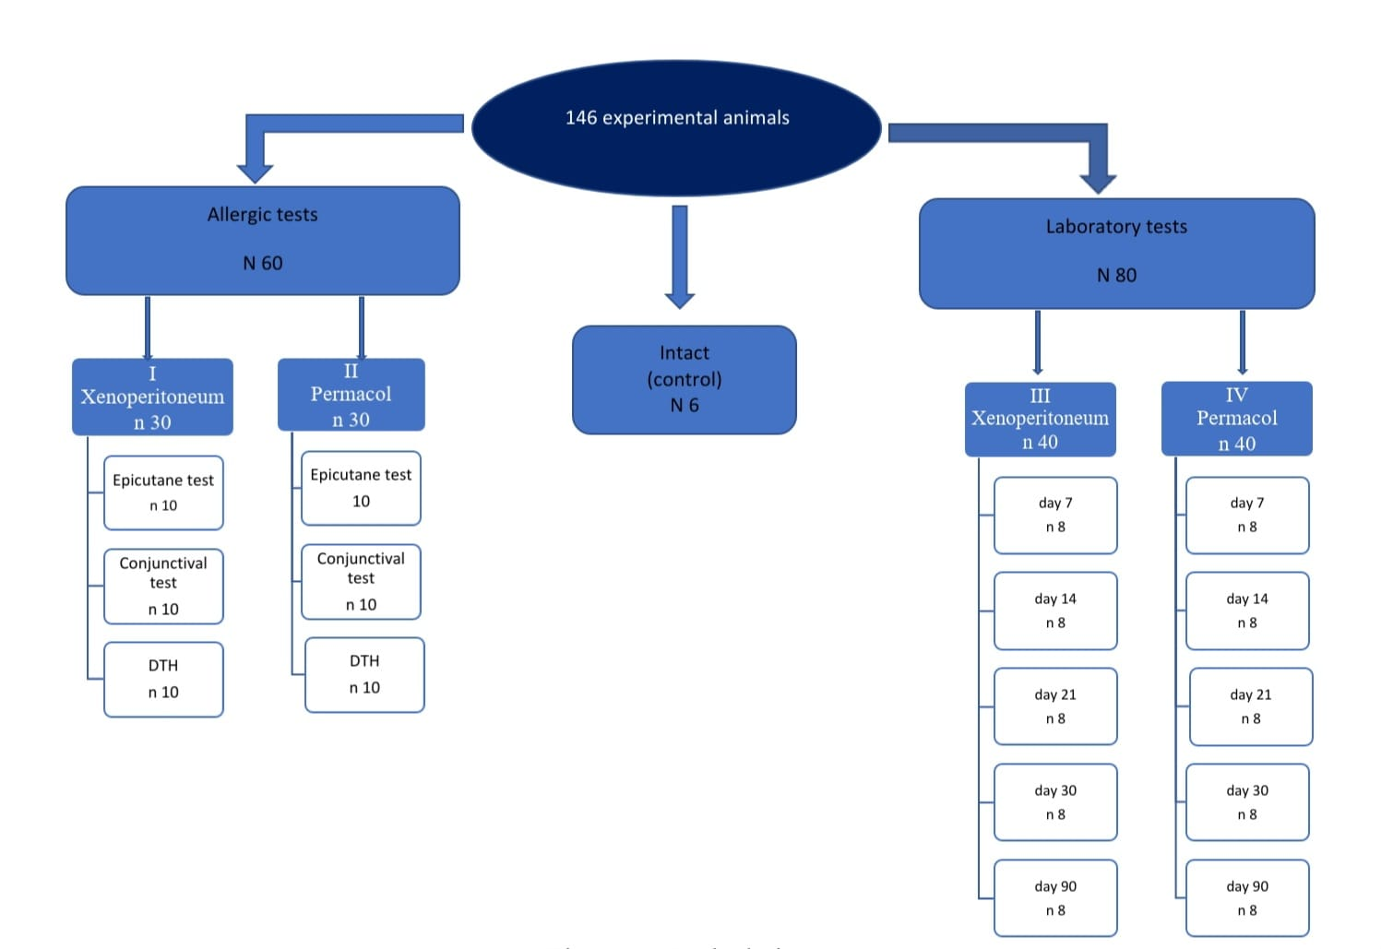

Figure 1 – Study design

**Research methods:**

* Anesthesia of laboratory animals was carried out under general ether anesthesia. To do this, the rat was placed in an induction chamber with a volume of 3 liters with 3 ml of diethyl ether («Reachim», Russia), the exposure time was 5 minutes.
* Before the experiment start, the primary sensitization of the animal was carried out by inserting a bioimplant into the anterior abdominal wall.
* Blood sampling for laboratory studies was performed by intracardiac puncture, followed by the removal of the animal from the experiment, in time, according to the design of the study.
* Antigenic properties were determined using epicutaneous sensitization by 20 repeated dermal applications of bioimplants, a conjunctival sample with aqueous solutions of bioimplants obtained by homogenization of the material in liquid nitrogen, and a «delayed» type hypersensitivity reaction on the 21st day by intradermal injection of an aqueous solution at the tail base in the volume of 0.05 ml containing dispersed bioimplants.
* Solid-phase chromogenic enzyme immunoassay was used to determine CIC, CRP, TNF-α and IL-2.
* The level of extracellular DNA, extracellular RNA, acid-soluble fraction (ASF) and quantitative determination of histone-like protein fractions were analyzed by spectrophotometry according to L. I. Markusheva et al. [16].

**Conclusions**

1. The extracellular xenoperitoneum matrix does not cause hypersensitivity of the «immediate» and «delayed» type at allergic tests *in vivo* and is identical in safety profile with the comparison material.

2. A comparative analysis of the dynamics of the systemic inflammatory response to implantation of decellularized xenoperitoneum matrix and acellular dermal collagen showed statistically significant differences in the levels of TNF-α and IL-2 in the group using decellularized xenoperitoneum matrix with the control group up to the 21st day by 2.24 times (p=0.03) and 1.88 times (0.03), respectively, CRP – up to the 7th day by 3.79 times (p=0.02).

A statistically significant increase was maintained in the levels of all CIC fractions for up to the 30th day in the group using the decellularized xenoperitoneum matrix: high-molecular CIC – in 7.25 times (p=0.01), medium-molecular CIC – in 4.41 times (0.03), low-molecular CIC – in 18.43 times (0.01). In the group using acellular dermal collagen, these results were as follows: high-molecular CIC – in 13.72 times (p=0.01), medium-molecular CIC – in 12.36 times (0.01), low-molecular CIC – in 26.87 times (0.01).

By the 90th day of observation, there were no statistically significant differences in both study groups from the control group (in the group using the decellularized xenoperitoneum matrix p=0.98 for IL-2, p=0.6 for CRP, p=0.3 for TNF-α, p=0.12 for high-molecular CIC, p=0.06 for medium-molecular CIC, p=0.07 for low-molecular CIC; in the group using acellular dermal collagen p=0.07 for IL-2, p=0.69 for CRP, p=0.3 for TNF-α p=0.11 for high-molecular CIC, p=0.06 for medium-molecular CIC, p=0.08 for low-molecular CIC), which reflects the physiological course of the postoperative period in the study group and the comparison group and indicates the absence of signs of chronic inflammatory process.

3. No significant differences were found between the groups when assessing the levels of extracellular nucleic acids and fractions of H1, H2A, H3, H4, H2B histone-like proteins, however, the level of extracellular nucleic acids increased by the 90th day (extracellular RNA in the study group by 20% (0.37 units/ml), p = 0.01; in the comparison group by 45% (0.45 units/ml), p= 0.01; extracellular DNA, respectively, by 32% (0.37 units/ml), p= 0.01 and by 57% (0.44 units/ml), p=0.006) with a simultaneous decrease of ASF and levels of H1, H2A, H3, H4, H2B histone-like proteins with no statistically significant differences (p<0.05), which can be considered as the final metabolic stages of the proliferative process and tissue remodeling.

**REFERENCES**

1. Flum D.R., Horvath K., Koepsell T. Have outcomes of incisional hernia repair improved with time? A population-based analysis. // Ann. Surg. – 2003. – №237. – P. 129–135.
2. Houck J.P., Rypins E.B., Sarfeh I.J., Juler G.L., Shimoda K.J. Repair of incisional hernia // Surg. Gynecol. Obstet. – 1989. – №169. – P. 397–399.
3. Dunne J.R., Malone D.L., Tracy J.K., Napolitano L.M. Abdominal wall hernias: risk factors for infection and resource utilization // J. Surg. Res. – 2003. – №111. – P. 78–84.
4. Luijendijk R.W., Hop W.C., Van den Tol M.P. A comparison of suture repair with mesh repair for incisional hernia // N. Engl. J. Med. – 2000. – №343. – P. 392–398.
5. Lo´pez-Cano M, Armengol-Carrasco M. Biological scaffolds in reparative surgery for abdominal wall hernias // Am. J. Surg. – 2012. – № 203. – 555 р.
6. Rozario T, DeSimone DW. The extracellular matrix in development and morphogenesis: a dynamic view // Dev Biol. – 2010. – №341. – P. 126–140.
7. Brown B., Lindberg K., Reing J., Stolz D.B., Badylak S.F. The basement membrane component of biologic scaffolds derived from extracellular matrix // Tissue Eng. – 2006. – №12. – P. 519–526.
8. Balayssac, D., Poinas, A. C., Pereira, B., & Pezet, D., Use of permacol in parietal and general surgery: a bibliographic review // Surgical innovation. – 2013. – V. 20. – №2. – P.176–182.
9. Smart, N. J., Marshall, M., & Daniels, I. R. Biological meshes: a review of their use in abdominal wall hernia repairs // The surgeon : journal of the Royal Colleges of Surgeons of Edinburgh and Ireland. – 2012. – V.10.- №3. – P.159–171.
10. Dirani, M., Chahine, E., D'Alessandro, A., Chouillard, M. A., Gumbs, A. A., & Chouillard, E. The use of Permacol biological mesh for complex abdominal wall repair // Minerva surgery. – 2022. – V.77. – №1. – P.41–49.
11. Doussot, A., Abo-Alhassan, F., Derbal, S., Fournel, I., Kasereka-Kisenge, F., Codjia, T., Khalil, H., Dubuisson, V., Najah, H., Laurent, A., Romain, B., Barrat, C., Trésallet, C., Mathonnet, M., & Ortega-Deballon, P. Indications and Outcomes of a Cross-Linked Porcine Dermal Collagen Mesh (Permacol) for Complex Abdominal Wall Reconstruction: A Multicenter Audit // World journal of surgery. – 2019. – V.43. №3. – P.791–797.
12. Russello, D., Sofia, M., Conti, P., Latteri, S., Pesce, A., Scaravilli, F., Vasta, F., Trombatore, G., Randazzo, V., Schembari, E., Barchitta, M., Agodi, A., & La Greca, G. A retrospective, Italian multicenter study of complex abdominal wall defect repair with a Permacol biological mesh // Scientific reports. – 2020. – V.10. №1. – P.3367.
13. Fatkhudinov, T., Tsedik, L., Arutyunyan, I., Lokhonina, A., Makarov, A., Korshunov, A., Elchaninov, A., Kananykhina, E., Vasyukova, O., Usman, N., Uvarova, E., Chuprynin, V., Eremina, I., Degtyarev, D., & Sukhikh, G. Evaluation of resorbable polydioxanone and polyglycolic acid meshes in a rat model of ventral hernia repair // Journal of biomedical materials research. Part B, Applied biomaterials. – 2019. – V.107. №3. – P.652–663.
14. Ball CG, Kirkpatrick AW, Stuleanu T, Rosen MJ, Eberle TL. Is the type of biomesh relevant in the prevention of recurrence following abdominal wall reconstruction? A randomized controlled trial // Can J Surg. – 2022. – V.65. №4. -P.541-549.
15. Development and application of the extracellular xenoperitoneum matrix in the surgical treatment of the anterior abdominal wall hernias: research report (interim) /Karaganda state med. univ-ty; supervisor: N. T. Abatov; executor: R. M. Badyrov [et al.]. – K., 2015. – 67 p. – No. ГР 0115RK00305. – Inv. No. 0215RK02890
16. Markusheva L. I., Savina M. I., Reshina V. M. et al. Nuclear chromatin proteins in the evaluation of the treatment effectiveness in patients with psoriasis //Clinical laboratory diagnostics. - 2000. – No. 7. – Pp. 18-20.